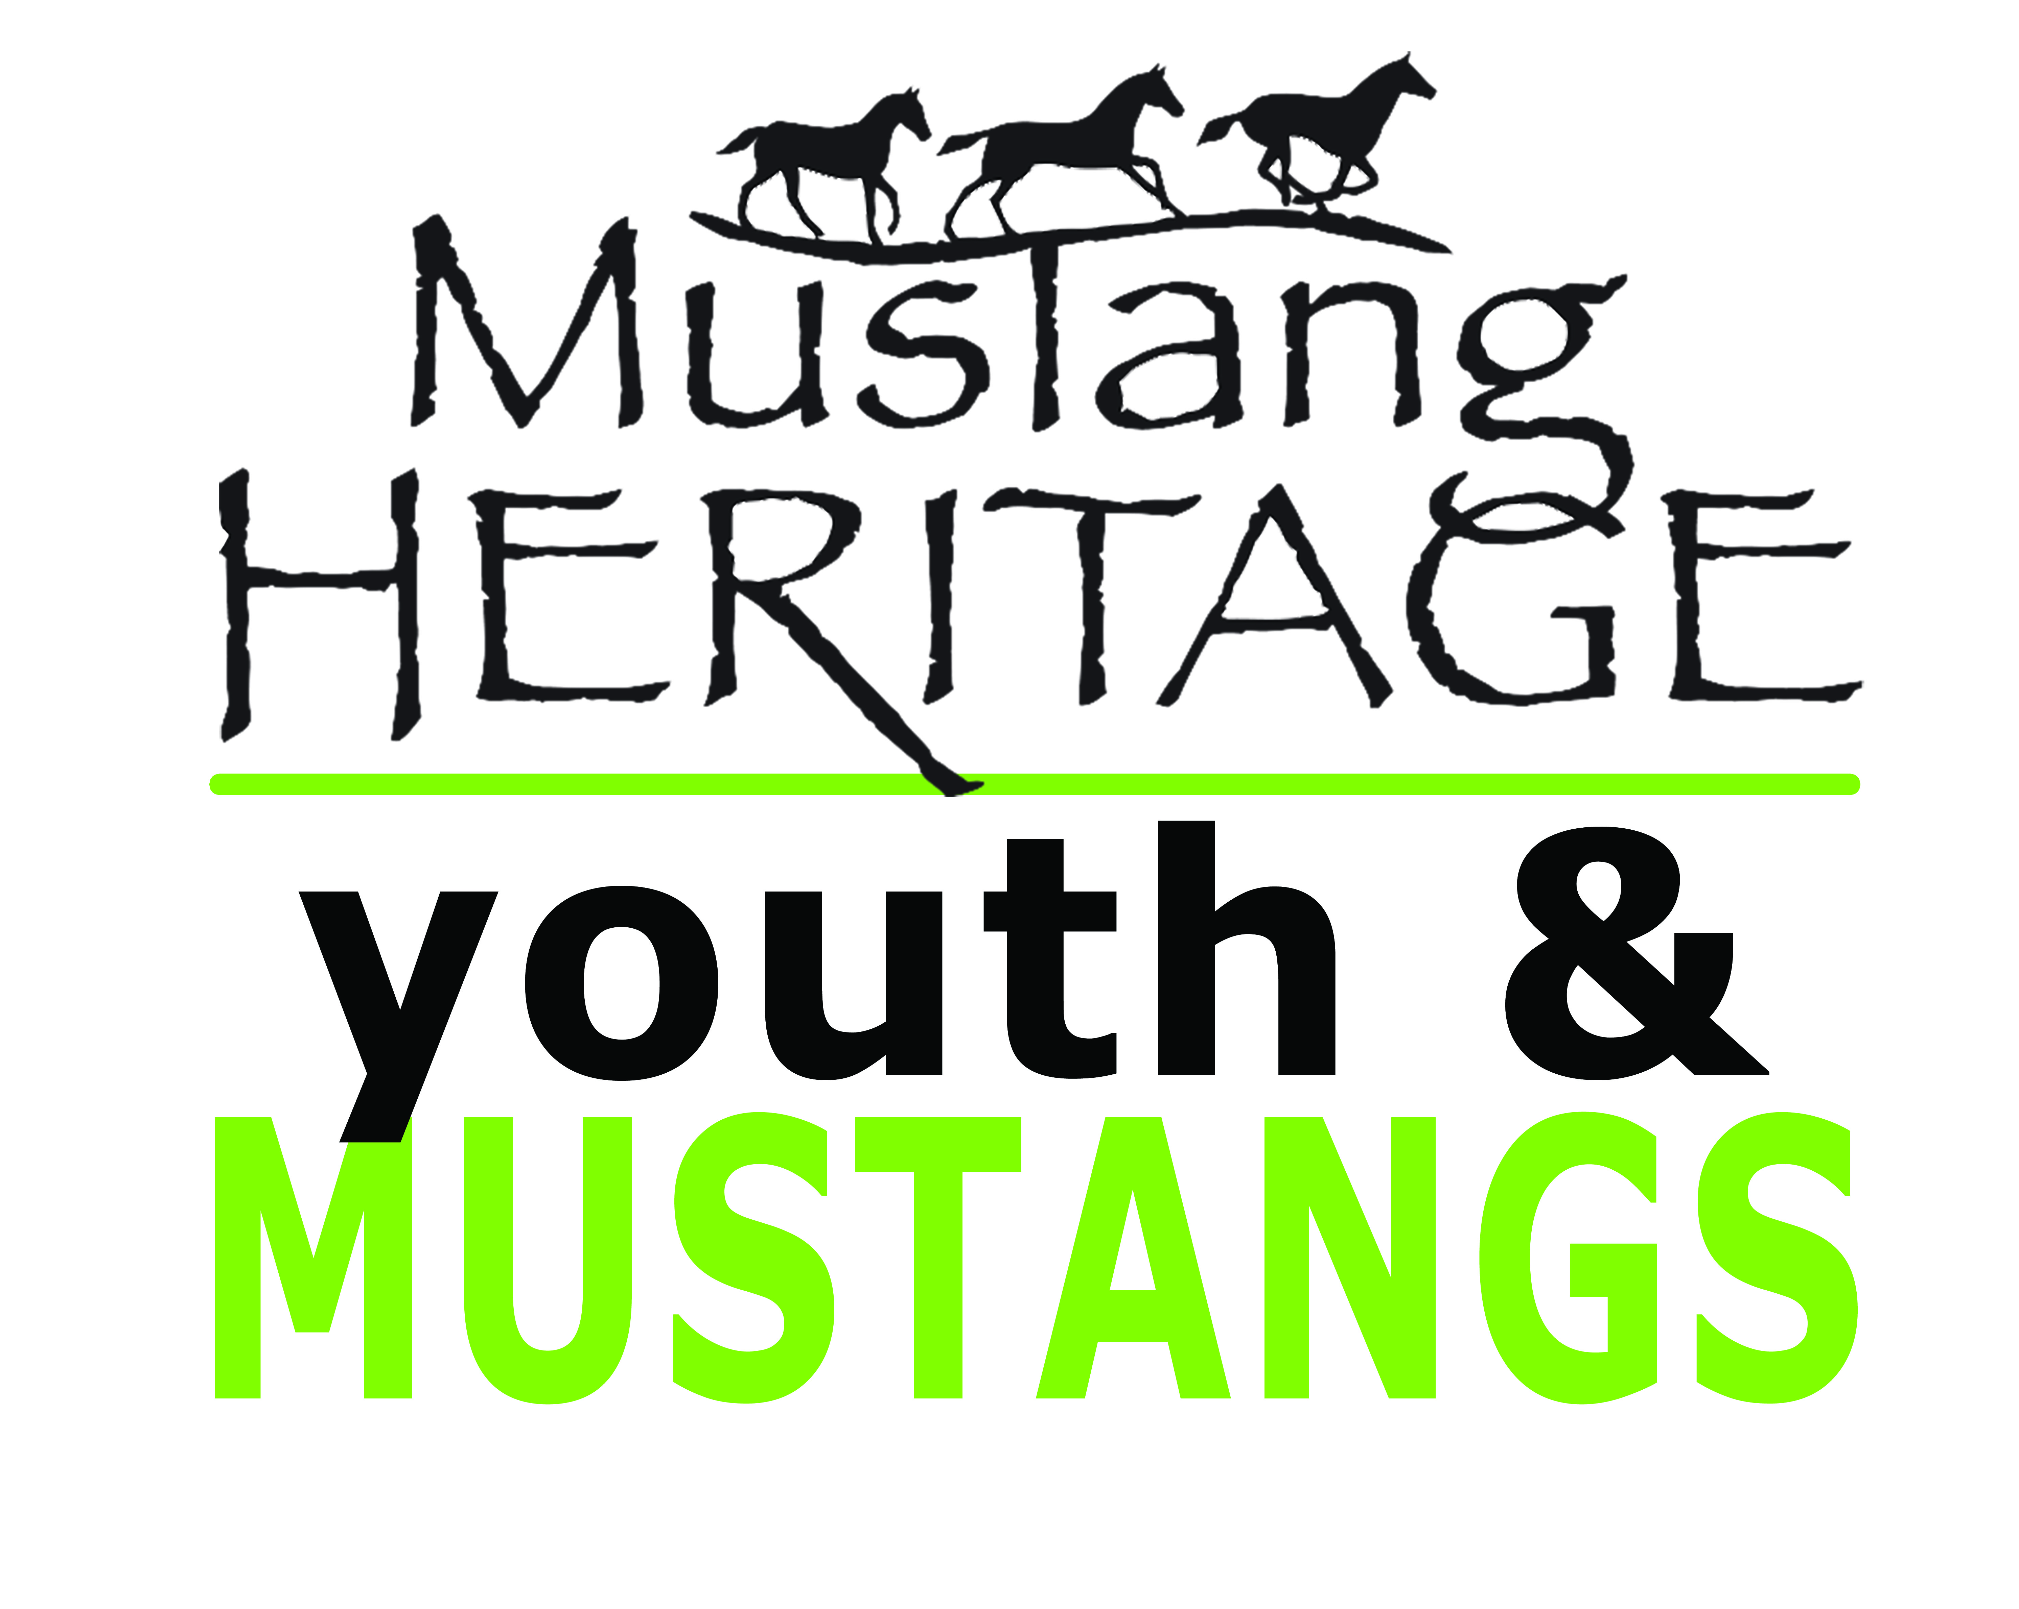

PURPOSE:

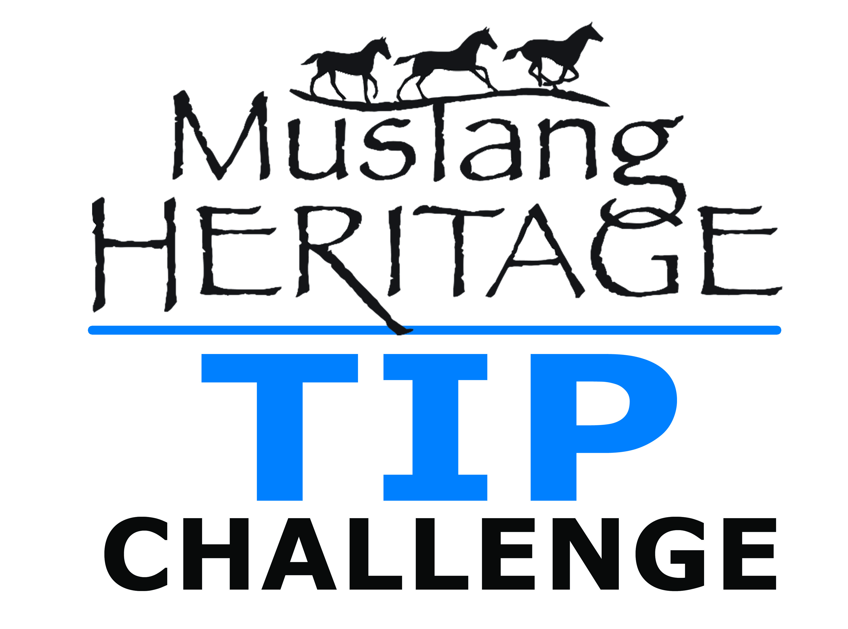
RULES & REGULATIONS

Youth & Mustang and TIP Challenge
Hosted by Impact of the Horse
Managed by Janet Tipton

November 9 & 10, 2018
Wasatch County Events Center, Heber, UT

The mission of the Mustang Heritage Foundation is to increase the adoption of BLM-housed American Mustangs & Burros through innovative gentling (training) competitions and awareness programs. In keeping with this mission, the TIP Challenge program has been created increase adoption and awareness of BLM-housed mustangs and burros by partnering with individuals and providing the funding and structure needed to host and manage localized mustang and/or burro in-hand training competition. Participating trainers help promote the adoption of these national treasures by showcasing the Mustang’s value and trainability.

OVERVIEW:

This TIP Challenge is a cooperative effort between the Mustang Heritage Foundation’s Trainer Incentive Program and the Bureau of Land Management’s Wild Horse and Burro Program and will be hosted and managed by the event coordinator, Janet Tipton.

- Trainers will be accepted to adopt one mustang for this competition. Youth competitors must be between the ages of 8 -17 at time of pick up in order to participate in the Youth Division. Adult Division is 18+.

- Interested trainers must complete and submit the trainer application with parent/guardian signatures (where applicable) and received by July 3, 2018, to Janet Tipton – 4912 Hazel Circle, Erda, UT 84074 or email to FlyingTAcres@gmail.com to be considered. There will be NO exceptions for late submissions.

- The trainer will be required to condition and train the mustang or burro for approximately 100 days and compete with his/her trained mustang or burro during the TIP Challenge at the Impact of the Horse on November 9 & 10, at the Wasatch County Events Center, in Heber, Utah, for prizes and awards.

- Selected trainers accepted will receive $200 from the Mustang Heritage Foundation (to be disbursed through the event manager) to offset horse care expenses and hauling costs upon appearance at the Utah Wild Horse & Burro Festival.

- Mustangs will be as comparable in size and age (12-24-months-old) as possible, with current vaccinations, health papers, and hooves trimmed.

- Mustangs will be scored on a handling/conditioning class and a 3 minute freestyle routine.

This program is intended to facilitate the adoption of Mustang horses ages 12-24 months old. The parent/guardian of the youth trainer is required to complete all necessary adoption paperwork for their assigned Mustang at pick-up.

REGULATIONS:
- Participation in this event is by selection only. Therefore the Mustang Heritage Foundation has the unqualified right to determine eligibility and can, at any time, remove an applicant or contestant from a program and/or competition for any reason or for no reason.
- All interested trainers must complete and submit a trainer application with parent/guardian signatures (where applicable) and received by July 3, 2018, to Janet Tipton – 4912 Hazel Circle, Erda, UT 84074 or emailed to FlyingTAcres@gmail.com, to be considered. There will be NO exceptions, no late submissions.
- Facility requirements: Facility can consist of a corral/paddock/stall/round pen. Facility must be a minimum of 400 square feet (for example 20 feet x 20 feet or 10 feet x 40 feet) and at least 5 feet high. Facility must be sturdy and constructed of materials such as poles, pipes, or planks (minimum 1.5 inch thickness) without dangerous protrusions. Barbed wire, large-mesh woven, stranded and electric materials are unacceptable for fencing.
Trainers should not release the Mustang into a large open area, such as a pasture, since they may not be able to recapture the animal for training or to provide veterinary care. However, once the animal is gentled, trainers may release it into a pasture or similar area.
Shelter for the Mustang may be provided from inclement weather and temperature extremes. Shelters should be a two-sided structure with a roof, well drained, adequately ventilated, and accessible to the Mustang. The two sides should block prevailing winds and protect the major body parts of the horse. Tarps are not acceptable. Contact the administering BLM office for shelter requirements in the area.
- Trailer requirements: You must provide transportation for your Mustang. While someone else may transport the animal, all trailers must meet these minimum standards: covered top, sturdy walls/floors, and a smooth interior free from any sharp protrusions; ample head room; removable partitions or compartments to separate animals by size and sex, if necessary; floor covered with a non-skid material; and, adequate ventilation. The BLM requires stock-type trailers with rear swing gates to transport adopted animals. Drop ramp, divided two-horse trailers, and trucks with stock racks are not acceptable.
- Trainer selection will be made based on experience, reference, and fulfillment of BLM requirements. Trainers must be experienced with horses and have the desire to tame and train a Mustang horse for competition.
- The event manager will be responsible for assigning one Mustang to each selected trainer.
- All trainers’ parents/guardians (where applicable) must adopt the assigned mustang before taking possession of it by completing and submitting a BLM adoption application, signing a Private Maintenance and Care Agreement (PMACA), and providing the responsible BLM office with a personal check in the amount of $25 made out to USDI/BLM (or the event manager may issue a single check to BLM on behalf of the adopters).
- The event manager may choose to either deliver Mustangs to selected trainers or hold a “pick up” at which selected trainers can pick up their Mustang.
- Trainers are responsible for all care-related costs from the day the mustang is picked up through the conclusion of the competition, including all feed, board, and veterinary care. Any fatality or significant injury should be report to Janet Tipton (801) 554-4431 immediately.
- Mustang training must be humane and compassionate. “Least resistance” techniques are encouraged.

- By participating in the TIP Challenge, trainers agree that all photos and filming become the property of the Mustang Heritage Foundation to be used to promote the event and Foundation.
- Conduct: Conduct shall be orderly, responsible, sportsmanlike and humane in the treatment of mustangs, and in keeping with positively promoting the implementation of the event and fair competition. This includes, but is not limited to: conduct while trainers have mustangs is in their possession; conduct on the show grounds; conduct while trainers are wearing Event logos on / off the show grounds; and includes the conduct of all individuals traveling with trainers, spectators or event managers and all other persons present on show grounds.
Any alleged unsportsmanlike or irresponsible conduct or any other form of misconduct, such as illegal, indecent or profane, and the inhumane treatment of horses are prohibited and shall be grounds for the disciplinary action against offending individuals. Further, event management may immediately expel offenders from the competition or show grounds in order to preserve the decorum of the show. Any applicant or selected individual may be removed from the selection process or this competition at any time if found to have any alleged history of cruelty to animals or humans.
- Sponsorships: The Mustang Heritage Foundation has entered into corporate sponsorship agreements with a variety of companies. The Foundation asks that trainers honor those sponsorships. Trainers will be restricted from wearing apparel or equine products during the competition that have logos that are larger than 4 inches wide and 2 inches tall.
- Winners will be announced immediately following the competition.
- Per BLM adoption rules, adopted Mustangs remain the property of the U.S. Government during the 12 month adoption period and cannot be sold during this time. Mustangs do not become personal property until the adopter applies for the ownership title following the 12 month adoption period and it has been approved and issued by BLM.
- If the youth trainer is unable to keep their Mustang after the competition, it is the responsibility of the trainer to find a new adopter for the Mustang. The original adopter must sign appropriate BLM relinquishment paperwork and the new adopter must sign appropriate BLM adoption paperwork in order to reassign the horse. If the trainer should decide to return their horse to the BLM after the competition they shall forfeit any & all monies payable to them including the $200 for feed/care expenses.

RULES:
- Fulfill all requirements related to hauling, stable facilities, care and training.
- All approved trainers are eligible to participate. Parents/guardians must sign all appropriate applications and Mustang adoption forms and must ultimately be responsible for the care of horses. Children may not receive assistance while in the arena competing.
- No substitution or replacement of the approved trainer will be allowed. The trainer who is accepted must be the individual that trains and competes. Trainers may receive help in the training and conditioning of their Mustang, but may NOT have assistance during the competition.
- Each trainer is required to submit pictures and updates on their progress by each of the following dates: August 5, August 19, September 2, September 16, September 30, October 14, October 28 and November 5 (more often is encouraged). Failure to do so WILL subject the Trainer to forfeiture of ALL prize money. Pictures and updates must be submitted to Janet @ FlyingTAcres@gmail.com in order to qualify. Pictures MUST be good quality (taken in good lighting) so as to be used in promotional activities for the adoption. A QUALITY head shot of trainer and horse (showing brand if possible) MUST be submitted by October 14.
- Each trainer and at least one responsible adult (for youth trainers) must attend at least one conference call (date to be identified at least two weeks prior) prior to the competition date.
- Trainers will receive $200 from the Mustang Heritage Foundation (to be disbursed through the event manager at the time of the competition) to offset horse care and travel expenses. The money must be returned to the MHF (through the event manager) if the horse is returned to the BLM or the event manager for any reason other than injury to self or horse. If the trainer must withdraw from the competition due to injury, he or she must supply a doctor or veterinarian note to the event manager describing the injury and/or reason why the trainer or Mustang will not be able to compete in order to receive the $200 reimbursement.
- Mustangs may be exhibited in English, Western or other appropriate equine styles. Silver on your equipment or sequins on your shirts will not earn you any extra points.

- Training aides will not be restricted, although trainers should realize that horses shown without the use of training aides may be scored higher.

- Trainers are not allowed to ride, sit or stand on their animals at any time prior to or during the competition. In addition, horses are not allowed to pull any items (carts, sleds, etc.), however the exhibitor may pull an item while leading the horse.
- A tie-breaker judge will be determined prior to the start of the competition in case of ties.
- Drugs: No person shall administer drugs internally or externally to a Mustang, either before or during the competition or adoption. Any medication, drug mechanical device or artificial appliance, which is of such character that it could affect performance or appearance at the event, is forbidden. If a Mustang is receiving medication for therapeutic purposes, the trainer must submit a letter from their veterinarian to the event manager as to the reason for medication and the prescribed amount. THE MUSTANG HERITAGE FOUNDATION RESERVES THE RIGHT TO DRUG TEST ANY MUSTANG IN THE COMPETITION.
- Class Competition Rules:
The competition can be based on 2 or more components: Conditioning (required), an In-Hand Trail Course, Showmanship, Horsemanship, Freestyle, etc. The event manager will determine classes, scoring values, and judges. Trainers are not allowed to ride the horses at any time.
  - Handling/Conditioning Class – trainers will be asked to exhibit required skills of a TIP trained horse (approach, halter, lead, pick up feet, load in a trailer) in a set pattern.

  - 3 Minute Freestyle – Trainers will be asked to perform a 3 minute freestyle routine which includes the following elements but are not limited to the following: (The ONLY props allowed during the freestyle are – Saddle, Rope, Bridge, Poles/Logs, Slicker) (Horse can be saddled or unsaddled during freestyle – however, please take into consideration it will be included in your time limit and points may be deducted if horses acts up) (Props can be used as jumps, however horse should not be required to jump any more than 18”). Music for Freestyle must be turned into Brooke Sweat by November 1, 2018. Music should be in an .mp3 format.
      - Walk and trot
      - Stop and back
      - Lead/Send horse over poles/logs

Mustangs will be scored on their responsiveness to these maneuvers.

AWARDS:
- All youth trainers competing in the event will receive $200 to help offset expenses related to horse care and travel.
- Additional awards and prizes will be determined by the event manager.

If you have any questions, please contact the event manager: Janet Tipton – (801) 554-4431 or FlyingTAcres@gmail.com.

