 | CONFEDERATION FOR WORKING EQUITATION  SHOW ENTRY FORM  GREAT BASIN WORKING EQUITATION SHOW  SHOW DATE(s): Aug 17 & 18, 2019 SHOW LICENSE No. CL19-044(P) |  |  |  |  |  |  |  | ENTRY NO:
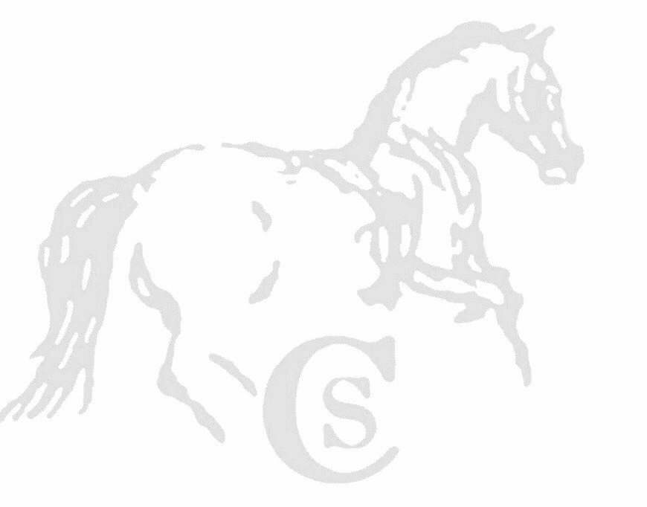 | SHOW SECRETARY  Simone Windeler, 19525 Twisted Pine Drive, Colorado Springs, CO 80908  719-287-2040 sagecreekshow@gmail.com  www.Equestrianentries.com |  |  |  |  |  |  |  | All information must be completed.  One entry form per horse.  Please submit entry to Show Secretary by: Aug 6, 2019  online by Aug 8, 2019
RIDER NAME |  |  | PHONE |  |  |  |  | LEVEL |  | FEES
STREET ADDRESS |  |  | CITY, STATE, ZIP |  |  |  |  | CHILDREN
EMAIL |  |  | ALTERNATE PHONE |  |  |  |  | L1 – INTRODUCTORY
GROUP MEMBER (if applicable) |  |  | MEMBERSHIP No. |  |  |  |  | L2 – NOVICE A
DATE OF BIRTH (Youth) |  |  | OPEN | AMATEUR |  | YOUTH |  | L3 – NOVICE B
HORSE NAME |  |  | BREED |  |  |  |  | L4 – INTERMEDIATE A
HORSE RECORDING No. |  |  | DATE OF COGGINS |  |  |  |  | L5 – INTERMEDIATE B
SEX |  | AGE | HEIGHT |  | COLOR |  |  | L6 – ADVANCED
OWNER NAME |  |  | PHONE |  |  |  |  | L7 – MASTERS
STREET ADDRESS |  |  | CITY, STATE, ZIP |  |  |  |  | OFFICE FEE
EMAIL |  |  | ALTERNATE PHONE |  |  |  |  | STALL FEE
GROUP MEMBER (if applicable) |  |  | MEMBERSHIP No. |  |  |  |  | LATE FEE
PAYMENT FORM |  |  | CHECK No. |  |  |  |  | OTHER
COMPLETE ONLY IF COMPETITION OFFERS CREDIT CARD PAYMENTS  (Check prize list or individual competition requirements)  CARD TYPE: EXP DATE: CVV:  CARD No.  NAME ON CARD:  BILLING ADDRESS |  |  |  |  |  |  |  | TOTAL FEES

This document waives important legal rights. Read it carefully before signing.

RELEASE:
I understand that this is a high-risk sport and I am participating at my own risk. I hereby assume this risk and further do hereby release and hold harmless the organizer (Licensee), organizing committee, competition management, judges and officials; the Confederation for Working Equitation (the “Confederation”), its officers, agents, employees and volunteers; the host of this event or competition; and the owners of any property on which the event or competition is being held, from all liability for negligence resulting in accidents, damage, injury, or illness to myself and to my property, including the horse or horses that I will compete at this event or competition.

CONFEDERATION ENTRY AGREEMENT:
By entering a Confederation-endorsed competition and signing this entry form as the Owner, Rider, or Parent/Guardian, I agree that I am subject to and agree to be bound by the Bylaws of the Confederation applicable to the Confederation-endorsed competition, the U.S. Rules for Working Equitation (“Rules”), and the requirements of the competition as stated in the Prize List. I will accept as final the decision of the Protests Committee or Appeals Committee on any question arising under the Rules and agree to release and hold harmless the competition, the Confederation, their officials, directors, and employees for any action taken under the Rules. I represent that I am eligible to enter and/or participate under the Rules and every horse I am entering is eligible as entered. I also agree that as a condition of and in consideration of acceptance of entry, the Confederation and/or competition management may use or assign photographs, videos, audios, cablecasts, or other likenesses of me and my horse taken during the course of the competition for the promotion, coverage, or benefit of the competition, sport, or the Confederation. Those likenesses shall not be used to advertise a product and they may not be used in such a way as to jeopardize amateur status. I hereby expressly and irrevocably waive and release any rights in connection with such use, including any claim to compensation, invasion of privacy, right of publicity, or to misappropriation. The Confederation is governed by the laws and the State of Texas; any action instituted against the Confederation must be filed in Texas State.

In consideration for my participation in this Competition, I AGREE to the following:
- I AGREE that the Confederation and the Competition as used herein include the Licensee and competition management, as well as all of their officials, officers, directors, employees, agents, personnel, volunteers, and Confederation affiliates.
- I AGREE that I choose to participate voluntarily in the Competition with my horse as a rider, owner, or parent/guardian of a junior exhibitor. I am fully aware and acknowledge that horse sports and the Competition involve inherent dangerous risks of accident, loss, and serious bodily injury including broken bones, head injuries, trauma, pain, suffering, or death (“Harm”).
- I AGREE to hold harmless and release the Confederation and the Competition from all claims for money damages or otherwise for any Harm to me or my horse and for any Harm of any nature caused by me or my horse to others, even if the Harm arises or results, directly or indirectly, from the negligence of the Confederation or the Competition.
- I AGREE to expressly assume all risks of Harm to me or my horse, including Harm resulting from the negligence of the Confederation or the Competition.
- I AGREE to indemnify (that is, to pay any losses, damages, or costs incurred by) the Confederation and the Competition and to hold them harmless with respect to claims for Harm to me or my horse, and for claims made by others for any Harm caused by me or my horse while at the Competition I have read the Rules about protective equipment (Article 1.9.1.i) and I understand that I am entitled to wear protective equipment without penalty. I acknowledge that the Confederation strongly encourages me to do so while WARNING that no protective equipment can guard against all injuries. I represent that I have the requisite training, coaching, and abilities to safely compete in this competition. If I am a parent or guardian of a junior exhibitor, I consent to the child’s participation, AGREE to all of the above provisions, and AGREE to assume all of the obligations of this Release on the child’s behalf. I understand and AGREE that all competitors under the age of 18 must wear an ASTM/SEI-approved safety helmet.
- I AGREE that if I am injured at this Competition, the medical personnel treating my injuries may provide information on my injury and treatment to the Confederation and competition management.

BY SIGNING BELOW, I AGREE to be bound by all applicable Confederation rules, all terms and provisions of this entry form, and all terms and provisions of the Prize List. If I am signing and submitting this Agreement electronically, I acknowledge that my electronic signature shall have the same validity, force, and effect as if I affixed my signature by my own hand.

OWNER/AGENT SIGNATURE  (Mandatory) | RIDER SIGNATURE  (Mandatory) | PARENT/GUARDIAN SIGNATURE  (For Riders under 18) (Mandatory)
PRINT NAME | PRINT NAME | PRINT NAME
RIDER EMERGENCY CONTACT INFORMATION (Name /Relationship) |  | PHONE

